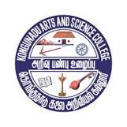
Kongunadu Arts and Science College (Autonomous) 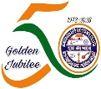
Reaccredited by NAAC with “A+” Grade (4th Cycle)

College of Excellence – (UGC)
29th Rank among Colleges in NIRF 2023
Coimbatore – 641029, Tamilnadu, India

DEPARTMENT OF INFORMATION TECHNOLOGY

Webinar on “Your Future with IoT “on 10.08.2023

Department of Information Technology organized a webinar on “Your Future with IoT” on 10.08.2023. The program was started at 3.00 PM through MS-Teams. The session started with the prayer song by R.Vaishnavi student of III B.Sc IT and Dr.K.Dhanalakshmi Head of the Department (i/c), has delivered the welcome address, Mrs.D. Princy introduced the chief guest Mr.Arunkumar Chandrasekaran, Delivery Governance Manager, Cognizant Technology Solutions Pvt Ltd, Chennai. He gave an introduction about the Internet of things (IoT) and described how the device access with sensors, processing ability of the system , software and other technologies that connect and exchange data with other devices and systems over the internet or other communication networks with real world examples. The department faculty members and a total of 112 students attended the programme and benefited. Dr.N.Alamelu Mangai gave vote of thanks. The webinar successfully ended at 4. 15 PM.
