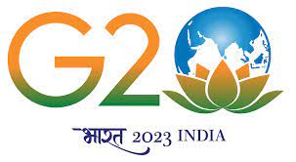 | KONGUNADU ARTS AND SCIENCE COLLEGE (Autonomous)  Re-accredited by NAAC with A⁺ Grade (4th cycle)  College of Excellence awarded by UGC  29th Rank among Colleges in NIRF 2023  Coimbatore – 641 029. | 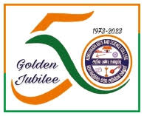

Date: 08.09.2023

The fifth day FDP topic is “Text to Understanding: A journey through Natural Language Processing”. The session starts at 5 pm through MS-Teams. The meeting was started with a prayer song by Ms.Viveka and Team from I B.Sc IT. Mrs.D.Princy, Assistant Professor, Department of Information Technology was the Master of Ceremony. Dr.K.Dhanalakshmi, Assistant Professor and Head(i/c), Department of Information Technology welcomed the gathering. Mrs.N.Deepa, Assistant Professor, Department of Information Technology introduced the Chief Guest. Dr.N.Alamelu Mangai, Assistant Professor, Department of Information Technology elaborated the mission of the topic.
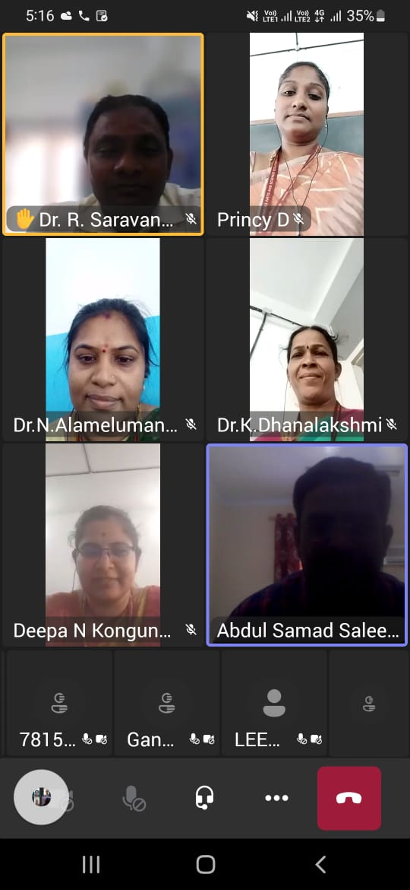

Dr.A.Saleem Raja, Associate Professor, Department of Information Technology, University of Technology and Applied Sciences, Oman was addressed the gathering about Natural Language Processing. He discussed about the most common Python NLP libraries, NLP key techniques, NLP Process flow. He also elaborated the concepts of Machine Learning Models, Deep Learning Models, and NLP learning resources. Ms. S.Aswini, Assistant Professor, Department of Information Technology delivered the Vote of Thanks. 285 participants attended the meeting and got benefited through the session.

KONGUNADU ARTS AND SCIENCE COLLEGE (Autonomous)
Re-accredited by NAAC with A⁺ Grade (4th cycle)
College of Excellence awarded by UGC
29th Rank among Colleges in NIRF 2023
Coimbatore – 641 029.
Date:14:09:2023
DEPARTMENT OF INFORMATION TECHNOLOGY

The Tenth day of Twelve Days Virtual Faculty Development Program on Developing Human Potentials in Emerging Technologies in Computer Science organized by the School of Computer Science, Kongunadu Arts and Science College, Coimbatore was held on 14th September 2023 at 5.00 pm to 07.00 pm (Thursday) for which Dr.Sivaraman Eswaran, ME, Ph.D., Senior Lecturer, Department of Electrical and Computer Engineering Program Co-ordinator, Bachelor of computing ( Cyber Security) Curtin University, Malaysia was a Resource Person.

The Master of Ceremony handled by Mrs. N.Deepa began session with her greetings and invited Ms.Vivekha and her Team from I B.Sc IT for the prayer song. Following it, the Welcome Address was given by Mrs.D.Princy which enlightened the gathering. The MoC next invited Dr.K.Dhanalaksmi, HoD (i/c) unveil the profile of the Guest to elevate the gathering. Then, MoC invited Ms.S.Aswini to brief the purpose of the session. Later the session was taken by the Guest.

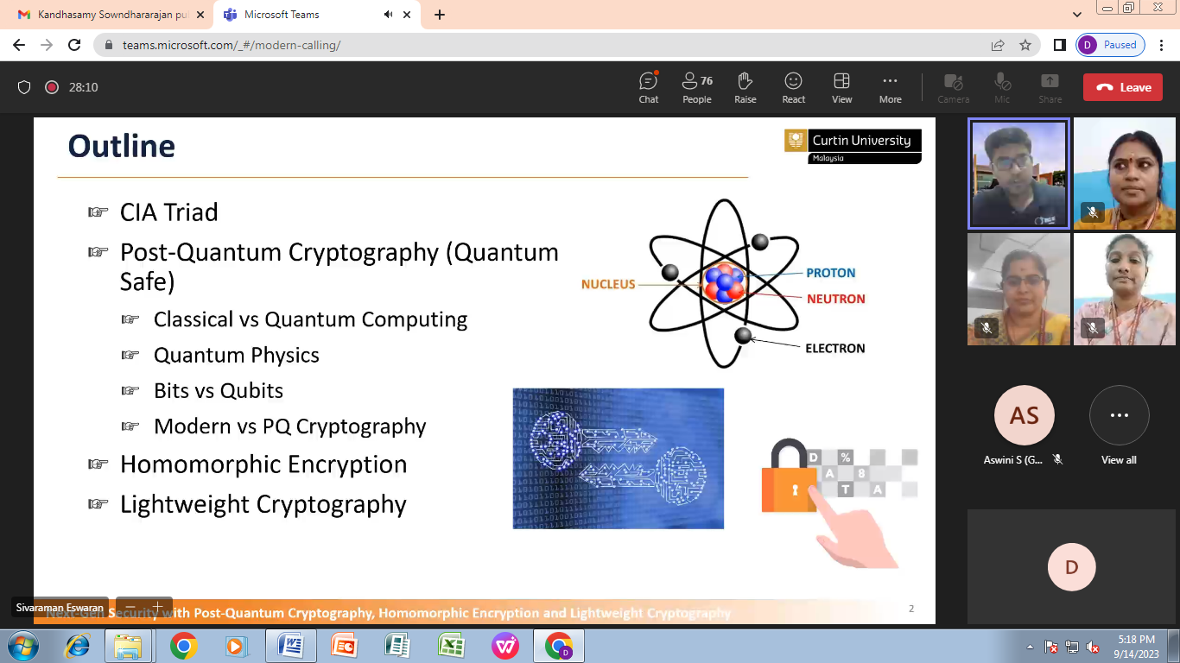
Dr.Sivaraman Eswaran in his talk, detailed about Next Gen Security with Post Quantum Cryptography, Homomorphic Encryption and Light weight Cryptography. He elucidated about securing quantum and classical computers. With real time case studies he showed the mathematical computations to be performed directly on the encrypted data. Later in his session he brushed about the IoT, RFID and light weight cryptographic algorithms. There was an interactive query session for which the resource person responded.

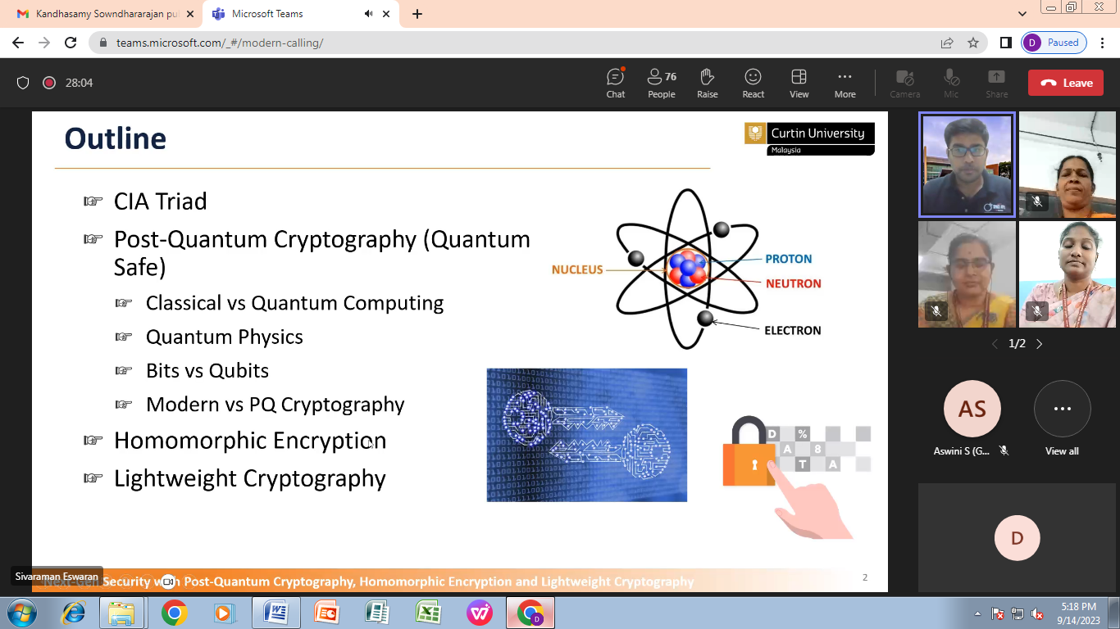

The session concluded with the Vote of Thanks given by Dr. N.Alamelu Mangai, and then feedback were collected. Totally, for the session Next Gen Security with Post Quantum Cryptography, Homomorphic Encryption and Light weight Cryptography 282 participants were benefitted.

