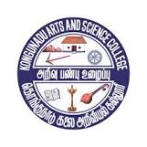
Kongunadu Arts and Science College (Autonomous) 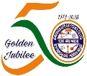
Reaccredited by NAAC with “A+” Grade (4th Cycle)
College of Excellence – (UGC)
29th Rank among Colleges in NIRF 2023
Coimbatore – 641029, Tamilnadu, India

DEPARTMENT OF INFORMATION TECHNOLOGY

Hands-on Workshop on “Angular JS” on 02.09.2023

Department of Information Technology organized a Hands-on Workshop on “Angular JS” on 02.09.2023 FN. The program began by 10.00 AM in Computer Lab- III. The session started with the prayer song by R.Vaishnavi student of III B.Sc IT and Dr.K.Dhanalakshmi Head of the Department (i/c), delivered the Welcome Address, Mrs. D. Princy introduced the Chief Guest Dr.N.Priyadharshini MCA., Ph.D., Assistant Professor, Department of Computer Technology and Data Science, Sri Krishna Arts and Science College, Coimbatore.
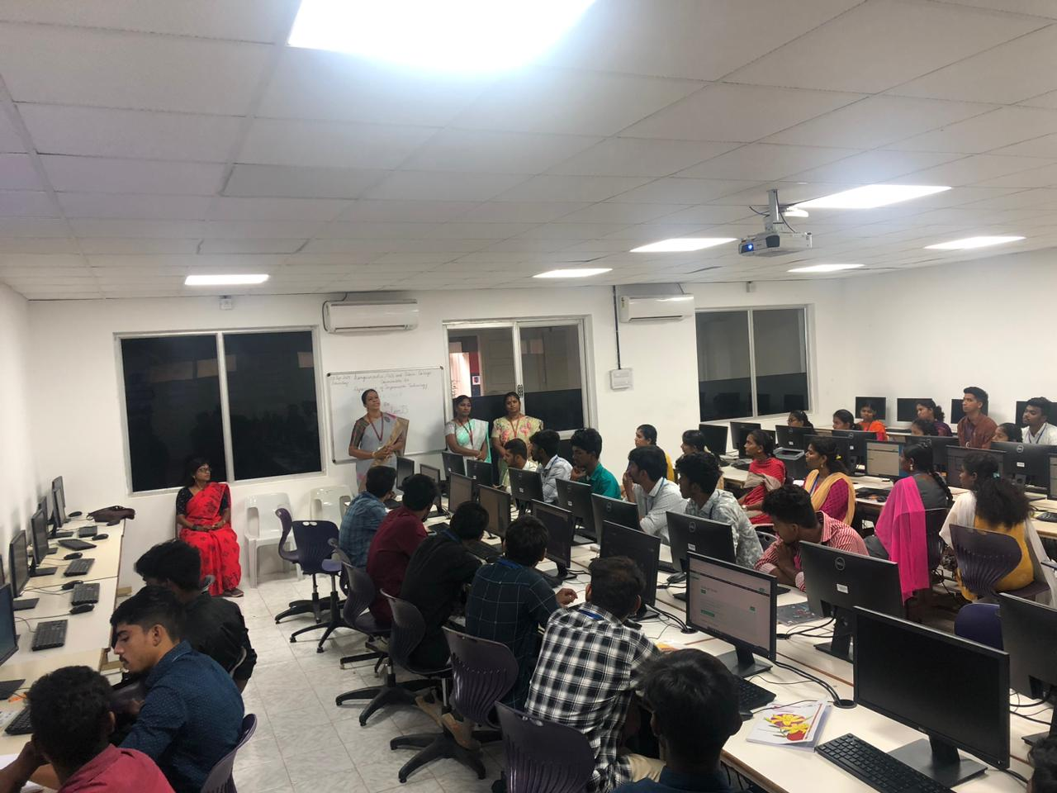
The session began with the guest introducing about Angular JS and a brief history of Angular JS. Angular JS is supported by Google, an open-source, JS based software engineering platform for building user interfaces (front end) its history traces back to 2009. Dr. N. Priyadharshini, built a single-page-client applications using HTML and Typescript and students were made to execute it. Angular JS uses node.js as its base for a large part of its building environment. Further, the students tried their hands on command – line interface (CLI) tools to make it easier to bootstrap and develop Angular Applications. And also she explained about the Visual Studio code a powerful source code editor that is available on windows.
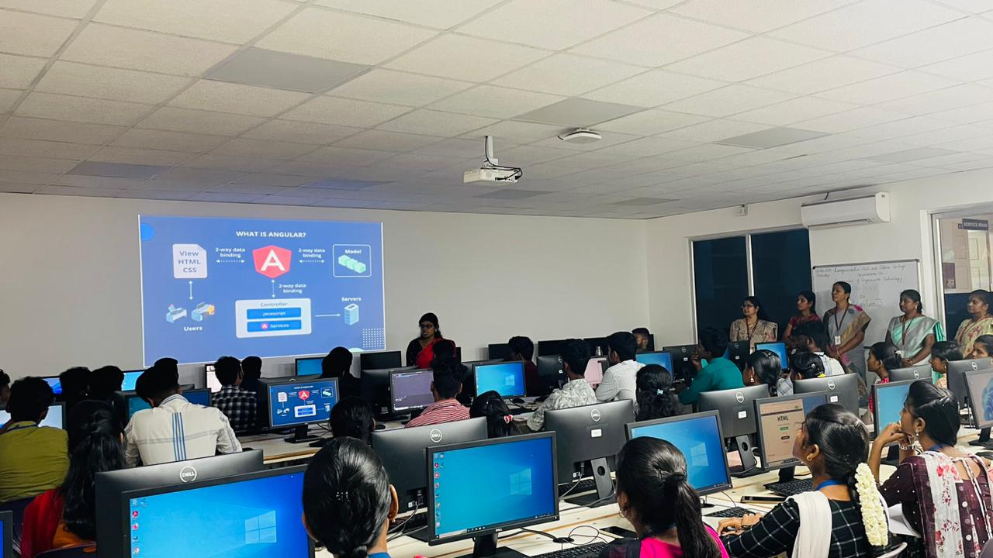
The workshop was attended by department faculty members and a total of 60 students were benefited. The session concluded with Dr.N.Alamelu Mangai’s vote of thanks. The webinar successfully came to an end at 1.30 PM.

