Kongunadu Arts and Science College (Autonomous)
College of Excellence (UGC)
Re-accredited by NAAC with “A⁺” Grade (4th Cycle)
29th rank among colleges in NIRF 2023
G.N. Mills (PO), Coimbatore-641029, Tamil Nadu, India.
&
தமிழ்நாடு அறிவியல் தொழில்நுட்ப மாநில மன்றம்
TAMILNADU STATE COUNCIL FOR SCIENCE AND TECHNOLOGY
DOTE Campus, Chennai – 600 025 & NCSTC, Government of India, New Delhi
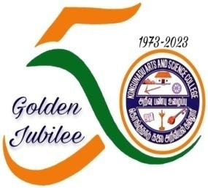
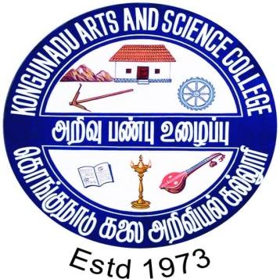
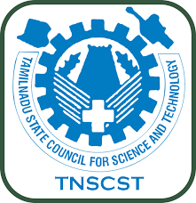

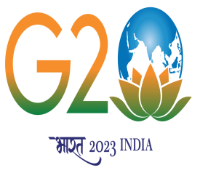

PG and Research Department of Biotechnology & Centre for Tribal Studies & Welfare Kongunadu Arts and Science College, Coimbatore will organize one day Awareness Programme on “Post COVID 19 Health and Hygiene Awareness Programme at Kotagiri Tribal Village, Nilgiris District under Popularization of Science Activities” on 24.09.2023 (Sunday) supported by Tamilnadu State Council for Science and Technology, Government of Tamilnadu, Chennai and NCSTC, Government of India, New Delhi.
The Objectives of the programme are,
- To promote health literacy and sanitation among tribal girls and women post covid-19
- To educate importance of balanced diet, mitigate and manage the risk of malnutrition prevalent among tribal women and girls between the age group of 11 and 60 years.
- The Resource persons of the programme will be Dr O N Paramasivan, F.R.C.S., Senior Orthopaedic Surgeon, Kovai Medical Centre and Hospital, Coimbatore and Dr Arjun Paramasivan, B.Sc. (Hons), M. B., Ch.B., (Leeds) M.R.C.S., Merseyside NHS trust, UK, Member of College Council, Kongunadu Arts and Science College, Coimbatore.
At the end of the session, Distribution of Balanced diet chart, Nutritional powder and Sanitary napkins will be given to the girls and women.

